|  |  |  |  |
| --- | --- | --- | --- |
|  | Assignment 3 | |  |
| Due Date: |  | | Marks: 2 |
|  | |

Answer following questions on paper (handwritten solution) with your name and ID on Top of each paper you posted,

1. Design all circuits of J-k, S-R, D and T flip flop with both active high and active low.

2. Draw state diagram and State table of the following circuits

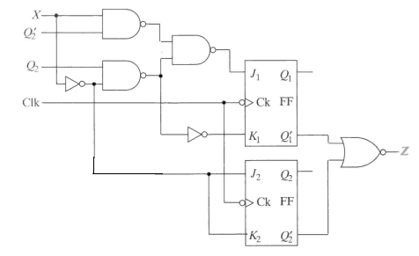

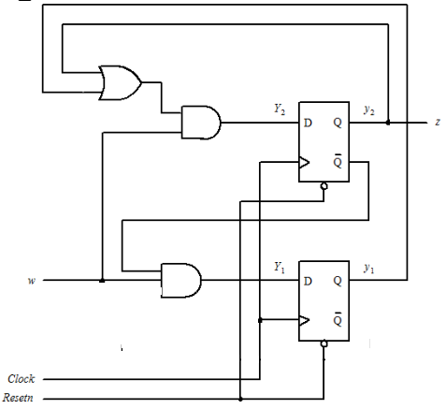

Submission Rules:

1. Only handwritten snaps are allowed.

2. Attach all snaps in a single word file or pdf with proper question numbering and sequence.

3. Submit a single doc or pdf file. Make a file named Assignment 3_<Student_name>e.g

Assignment 3_Awais.docx

4. Do write your name and ID on top of every snap

5. If any two submissions are found copied both will get zero marks.